Chapter 2 The Government of South Carolina

TRUE/FALSE

1. Congress is the lawmaking body in South Carolina.

ANS: F
The General Assembly is the lawmaking body in South Carolina.

PTS: 1 DIF: Knowledge REF: Chapter 2 Section 1
TOP: Legislative Branch

2. All bills to be considered by the South Carolina legislature must first go through the governor.

ANS: F
All bills to be considered by the South Carolina legislature start in either the Senate or House of Representatives.

PTS: 1 DIF: Comprehension REF: Chapter 2 Section 1
TOP: Legislative Branch

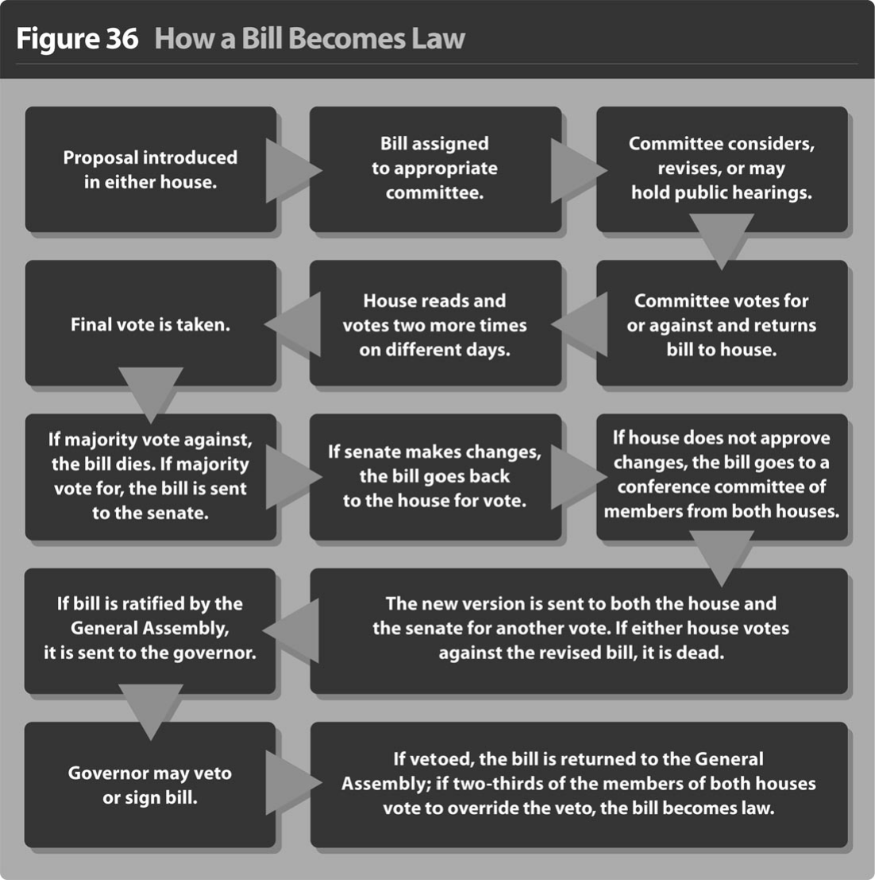

3. According to the chart, committees must hold public hearings on any bill they are considering.

ANS: F
According to the chart, committees may hold public hearings on any bill they are considering.

PTS: 1 DIF: Application REF: Chapter 2 Section 1
TOP: How a Bill Becomes a Law

4. According to the chart, if the Senate makes changes to a House bill, it dies.

ANS: F
According to the chart, if the Senate makes changes to a House bill, the bill goes back to the original house for a vote.

PTS: 1 DIF: Application REF: Chapter 2 Section 1
TOP: How a Bill Becomes a Law

5. According to the chart, if a committee approves a bill, it is sent to the full house for consideration.

ANS: T PTS: 1 DIF: Application REF: Chapter 2 Section 1
TOP: How a Bill Becomes a Law

6. The South Carolina Court of Appeals tries cases and hears appeals.

ANS: F
The South Carolina Court of Appeals does not try cases. It only hears appeals.

PTS: 1 DIF: Comprehension REF: Chapter 2 Section 1
TOP: Judicial Branch

7. South Carolina’s Supreme Court has five justices.

ANS: T
The South Carolina Supreme Court has five justices--one of whom is the chief justice.

PTS: 1 DIF: Application REF: Chapter 2 Section 1
TOP: Judicial Branch

8. Special interest groups hire lobbyists to try to influence legislators to vote for bills that would benefit their organizations.

ANS: T PTS: 1 DIF: Comprehension
REF: Chapter 2 Section 2 TOP: Vocabulary

9. The freedoms that you enjoy as a U.S. citizen are absolute.

ANS: F
The freedoms that you enjoy as a U.S. citizen are not absolute.

PTS: 1 DIF: Comprehension REF: Chapter 2 Section 2
TOP: Citizenship

10. Circuit Courts hear both civil and criminal cases.

ANS: T PTS: 1 DIF: Comprehension
REF: Chapter 2 Section 1 TOP: Judicial Branch

MULTIPLE CHOICE

1. What service is NOT supplied by a special service district?
a. | fire
b. | library
c. | sewer
d. | water

ANS: B PTS: 1 DIF: Comprehension
REF: Chapter 2 Section 2 TOP: Local Government

2. What is the name of South Carolina’s lawmaking body?
a. | Congress
b. | General Assembly
c. | House of Delegates
d. | House of Representatives

ANS: B PTS: 1 DIF: Knowledge REF: Chapter 2 Section 1
TOP: Legislative Branch

3. What is the only state-level body that can levy taxes, fees and fines to raise revenue?
a. | executive branch
b. | judicial branch
c. | legislative branch
d. | Supreme Court

ANS: C PTS: 1 DIF: Application REF: Chapter 2 Section 1
TOP: Legislative Branch

4. In what type of government does the power to govern come from the people?
a. | aristocracy
b. | democracy
c. | dictatorship
d. | oligarchy

ANS: B PTS: 1 DIF: Comprehension
REF: Chapter 2 Introduction TOP: Vocabulary

5. According to the chart, what is the correct sequence of events for a bill to become a law?
 | 1. | A bill is assigned to a committee.
 | 2. | Copies of the bill are given to all members of the house.
 | 3. | The governor may sign or veto the bill.
 | 4. | A bill is sent to the full chamber of the legislature.

a. | 1-2-4-3
b. | 4-2-1-3
c. | 2-1-4-3
d. | 4-1-2-3

ANS: A PTS: 1 DIF: Application REF: Chapter 2 Section 1
TOP: How a Bill Becomes a Law

6. What action is needed to pass a bill over the governor’s veto?
a. | a plurality vote of the people
b. | a majority vote of the people
c. | a two-thirds vote of both houses
d. | a three-fourths vote of both houses

ANS: C PTS: 1 DIF: Application REF: Chapter 2 Section 1
TOP: How a Bill Becomes a Law

7. Which is the lowest level court at the county level?
a. | Family Court
b. | Magistrate Court
c. | Municipal Court
d. | Probate Court

ANS: B PTS: 1 DIF: Knowledge REF: Chapter 2 Section 1
TOP: Judicial Branch

8. Which is not a requirement to run for Governor in South Carolina?
a. | at least 30 years of age
b. | a U.S. citizen
c. | a lawyer
d. | state residency for at least 5 years

ANS: C PTS: 1 DIF: Comprehension
REF: Chapter 2 Section 1 TOP: Executive Branch

9. Which is NOT a duty of the governor of South Carolina?
a. | to keep order
b. | to carry out the laws
c. | to be a spokesperson for the state
d. | to approve all the bills passed by the legislature

ANS: D PTS: 1 DIF: Analysis REF: Chapter 2 Section 1
TOP: Executive Branch

10. Which statement BEST describes a reason why giving the governor the power to submit a budget each year to the legislature is important?
a. | It allows the governor to set priorities.
b. | It brings more money into the governor’s office.
c. | It gives the governor control over the state revenue.
d. | It allows the governor to reward his or her supporters.

ANS: A PTS: 1 DIF: Analysis REF: Chapter 2 Section 1
TOP: Executive Branch

11. Which is an informal power of the Governor of South Carolina?
a. | to submit an executive budget to the legislature
b. | to be able to veto acts of the General Assembly
c. | to fill a number of offices with political supporters
d. | to deal with crises such as natural disasters and riots

ANS: C PTS: 1 DIF: Analysis REF: Chapter 2 Section 1
TOP: Executive Branch

12. Which court is responsible for determining if there is probable cause to send a person accused of a crime before a grand jury?
a. | Circuit Court
b. | Magistrate Court
c. | Probate Court
d. | Supreme Court

ANS: B PTS: 1 DIF: Comprehension
REF: Chapter 2 Section 1 TOP: Judicial Branch

13. Which court deals primarily with wills and deeds?
a. | Family Court
b. | Magistrate Court
c. | Municipal Court
d. | Probate Court

ANS: D PTS: 1 DIF: Comprehension
REF: Chapter 2 Section 1 TOP: Judicial Branch

14. Which courts are established by towns and cities?
a. | Circuit Courts
b. | Magistrate Courts
c. | Municipal Courts
d. | Probate Courts

ANS: C PTS: 1 DIF: Comprehension
REF: Chapter 2 Section 1 TOP: Judicial Branch

15. Which court is primarily a trial court?
a. | Circuit Court
b. | Family Court
c. | Magistrate Court
d. | Probate Court

ANS: A PTS: 1 DIF: Comprehension
REF: Chapter 2 Section 1 TOP: Judicial Branch

16. Which is NOT a duty of the South Carolina Supreme Court of Appeals?
a. | It has the last word on legal issues.
b. | It sets standards of ethical behavior for the profession.
c. | It disciplines lawyers and judges who engage in unethical behavior.
d. | It determines the constitutionality of each bill before the legislature.

ANS: D PTS: 1 DIF: Analysis REF: Chapter 2 Section 1
TOP: Judicial Branch

17. Which is NOT a service of county government?
a. | fire protection
b. | libraries
c. | parks
d. | roads

ANS: A PTS: 1 DIF: Application REF: Chapter 2 Section 2
TOP: Local Government

18. Which freedom is NOT included in the United States Constitution?
a. | freedom of assembly
b. | freedom of choice
c. | freedom of press
d. | freedom of religion

ANS: B PTS: 1 DIF: Comprehension
REF: Chapter 2 Section 2 TOP: Citizenship

19. Which of the following is a right of citizenship?
a. | voting
b. | paying taxes
c. | possessing guns
d. | serving on juries

ANS: C PTS: 1 DIF: Application REF: Chapter 2 Section 2
TOP: Citizenship

20. Which is a responsibility of citizenship?
a. | going to church
b. | paying taxes
c. | speaking freely
d. | demonstrating peacefully

ANS: B PTS: 1 DIF: Analysis REF: Chapter 2 Section 2
TOP: Citizenship

21. What action does NOT occur in a legislative committee?
a. | killing a bill
b. | revising a bill
c. | signing a bill into law
d. | holding public hearings

ANS: C PTS: 1 DIF: Comprehension
REF: Chapter 2 Section 1 TOP: Legislative Branch

22. How many consecutive terms can a person serve as South Carolina’s governor?
a. | 2
b. | 3
c. | 4
d. | 5

ANS: A PTS: 1 DIF: Knowledge REF: Chapter 2 Section 1
TOP: Executive Branch

COMPLETION

1. The two houses of the South Carolina General Assembly are the House of Representatives and the _____________________________.

ANS: Senate

PTS: 1 DIF: Knowledge REF: Chapter 2 Section 1
TOP: Legislative Branch

2. The length of one term in the South Carolina House of Representatives is _____________ years.

ANS: 2

PTS: 1 DIF: Knowledge REF: Chapter 2 Section 1
TOP: Legislative Branch

3. The length of one term in the South Carolina Senate is ____________ years.

ANS: 4

PTS: 1 DIF: Knowledge REF: Chapter 2 Section 1
TOP: Legislative Branch

4. The presiding officer of South Carolina’s Senate is the ______________________________.

ANS: lieutenant governor

PTS: 1 DIF: Knowledge REF: Chapter 2 Section 1
TOP: Legislative Branch

5. Most of the work in the General Assembly is done in _______________________________.

ANS: committees

PTS: 1 DIF: Comprehension REF: Chapter 2 Section 1
TOP: Legislative Branch

6. The governor heads the _______________________ branch of government.

ANS: executive

PTS: 1 DIF: Knowledge REF: Chapter 2 Section 1
TOP: Executive Branch

7. A(n) ____________________________________ is a group of people with similar ideas of how a government should be run.

ANS: political party

PTS: 1 DIF: Comprehension REF: Chapter 2 Section 2
TOP: Vocabulary

MATCHING

Match the term with its definition.
a. | appeal | h. | incorporated
b. | aristocracy | i. | lobbyist
c. | authoritarian | j. | monarchy
d. | bail | k. | oligarchy
e. | democracy | l. | patronage
f. | dictator | m. | probable cause
g. | filibuster | n. | revenue

1. rule by one person, e.g., king, emperor

2. rule by the people

3. operational funds for the government

4. recognized by the state as a legal governing body

5. power to distribute offices, grant favors, or promote an agenda

6. take to a higher court for rehearing

7. money deposited with the court by the accused to guarantee his or her appearance in court

8. ruled by a small class of people that inherit their authority

9. a reasonable expectation that evidence will be found

10. gains and keeps power by force

11. person who influences legislators to vote for bills that benefit the organizations they represent

12. gives great power to government

13. a rule that allows unlimited debate

14. rule by only a few people

1. ANS: J PTS: 1 DIF: Knowledge REF: Chapter 2 Introduction
TOP: Vocabulary

2. ANS: E PTS: 1 DIF: Knowledge REF: Chapter 2 Introduction
TOP: Vocabulary

3. ANS: N PTS: 1 DIF: Knowledge REF: Chapter 2 Section 1
TOP: Vocabulary

4. ANS: H PTS: 1 DIF: Knowledge REF: Chapter 2 Section 2
TOP: Vocabulary

5. ANS: L PTS: 1 DIF: Knowledge REF: Chapter 2 Section 1
TOP: Vocabulary

6. ANS: A PTS: 1 DIF: Knowledge REF: Chapter 2 Section 1
TOP: Vocabulary

7. ANS: D PTS: 1 DIF: Knowledge REF: Chapter 2 Section 1
TOP: Vocabulary

8. ANS: B PTS: 1 DIF: Knowledge REF: Chapter 2 Introduction
TOP: Vocabulary

9. ANS: M PTS: 1 DIF: Knowledge REF: Chapter 2 Section 1
TOP: Vocabulary

10. ANS: F PTS: 1 DIF: Knowledge REF: Chapter 2 Introduction
TOP: Vocabulary

11. ANS: I PTS: 1 DIF: Knowledge REF: Chapter 2 Section 2
TOP: Vocabulary

12. ANS: C PTS: 1 DIF: Knowledge REF: Chapter 2 Introduction
TOP: Vocabulary

13. ANS: G PTS: 1 DIF: Knowledge REF: Chapter 2 Section 1
TOP: Vocabulary

14. ANS: K PTS: 1 DIF: Knowledge REF: Chapter 2 Introduction
TOP: Vocabulary

ESSAY

1. Identify the responsibilities of citizenship and tell why each is important.

ANS:
Answers will vary, but may include:

-Voting: Some fear democratic government will not last if people do not take an active interest in government and vote. Some fear government will be taken over by wealthy persons who only have their interests at heart.
-Obeying laws: Laws bring order to our society. Without laws, there would be chaos.
-Serving on juries: Those who break laws need to be tried by a jury of their peers.
-Paying taxes: Tax money is needed to pay for public services.
-Staying informed: Citizens can stay informed by reading the newspaper, listening to the radio, watching television, attending or following proceedings of government meetings, and talking with other informed citizens.
-Getting involved: Citizens can get involved by helping candidates run for public office, running for public office themselves, participating in community service projects, serving in the military, debating public issues, and volunteering time with civic groups.

PTS: 1 DIF: Comprehension REF: Chapter 2 Section 2
TOP: Citizenship

2. What would your life be like if there were no laws?

ANS:
Answers will vary, but may include the ideas of chaos and anarchy.

PTS: 1 DIF: Analysis REF: Chapter 2 Section 2
TOP: Citizenship

